**Analysis of Novint Falcon Haptic Device as Manipulator**

Sichao Zhang, Peiguang Wang

**Motivation**

Novint Falcon is a parallel haptic device like Stewart platform, however, it only has three transitional DOFs. As Figure 1 shows, end effector of the Novint Falcon is attached by three kinematic chians actuated by three motor rotors respectively and each of the chain consists of four links. This haptic device is initially designed to be external device for shooting video games, but in this project, we analyze the Novint Falcon as the manipulator and controls it to solve the pinball maze problem. Pinball maze is a small

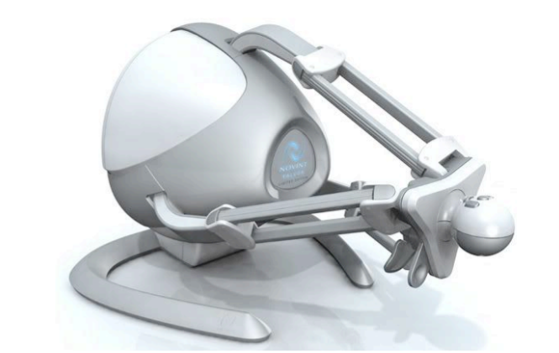

Figure Novint Falcon [1]

**Methods**

1. Forward Kinematics

The kinematic configuration was first introduced by Tsai and Stamper in the 1997 technical research report [2]. Three kinematic chains are connected to the end effector platform which is always parallel to the basement. And each chain contains four links with revolute joints connected. Based on the kinematic configuration, we derive the DH parameter table for each leg, which is shown in Table 1.

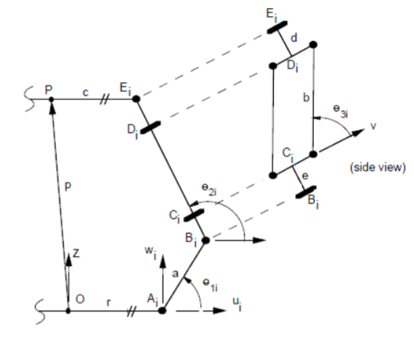

Figure Kinematic Configuration of Each Chain [2]

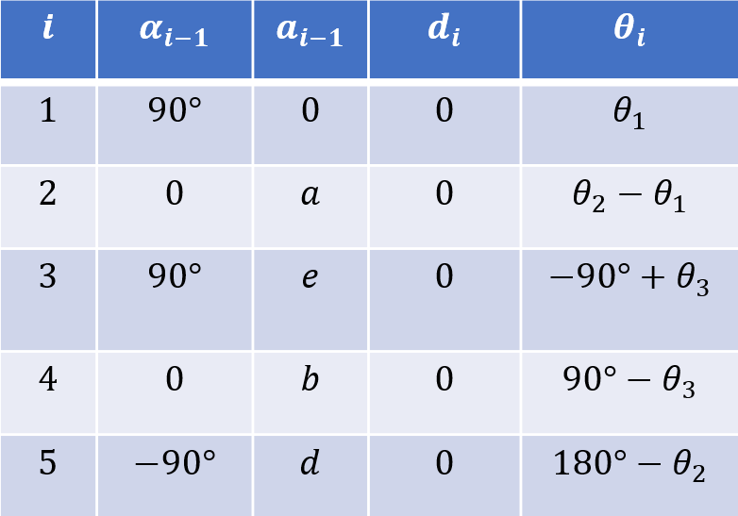

Table DH Parameter of Each Chain

1. Inverse Kinematics [2]

The inverse kinematics of Novint Falcon can be stated as to calculate the angular position of each joint using the position of end effector. Denote as the position of center of end effector platform with respect to the center of basement, and subscript as the *i*-thkinematic chain. In addition, a coordinate frame is defined for each kinematic chain, attached at the joint at the end of each kinematic chain. The position of can be expressed as

Where represents rotation angle of each with respect to the center of basement and .

From above, can be obtained from . In addition, can be generated by using the following substitution:

Where is the root of the equation, and

Finally, can be obtained from .

What should be noted is that there may be two or more solutions of each kinematic chain, so it is necessary to check which is the best solution, in other word, to find which is the nearest position with respect to the previous one.

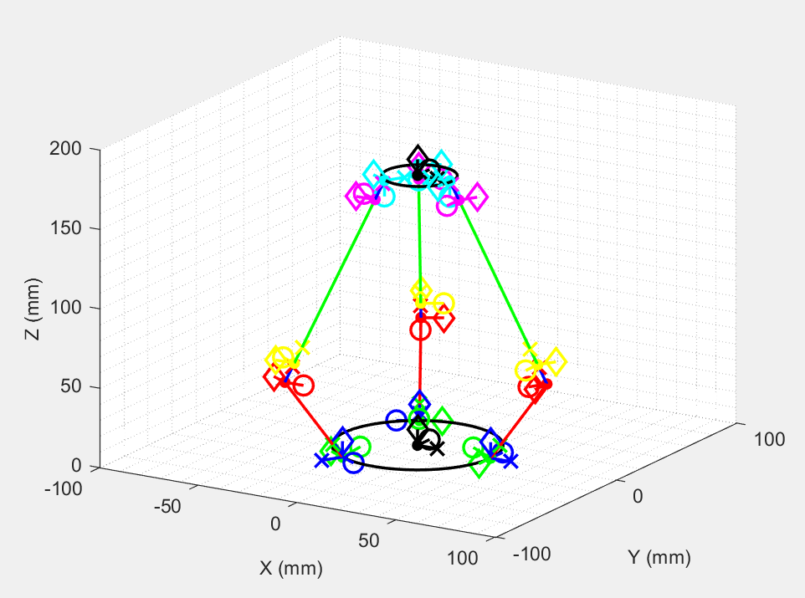

Figure MATLAB Simulation of Kinematic Configuration (p=(0;0;170))

1. Dynamics [3]

The following equation describes the dynamic model:

Following unknown parameters is identified as [3]

In addition, J represents the Jacobian matrix of the system, and J can be obtained from

Where

And is the acceleration of the end effector, .

1. Path Generation

This problem is meant to solve the pinball maze problem in geometric configuration. Pinball maze, also referred to ball-in-a-maze puzzle, is a small gadget that people should rotate or maneuver the maze and makes the ball in the maze reach the goal point.

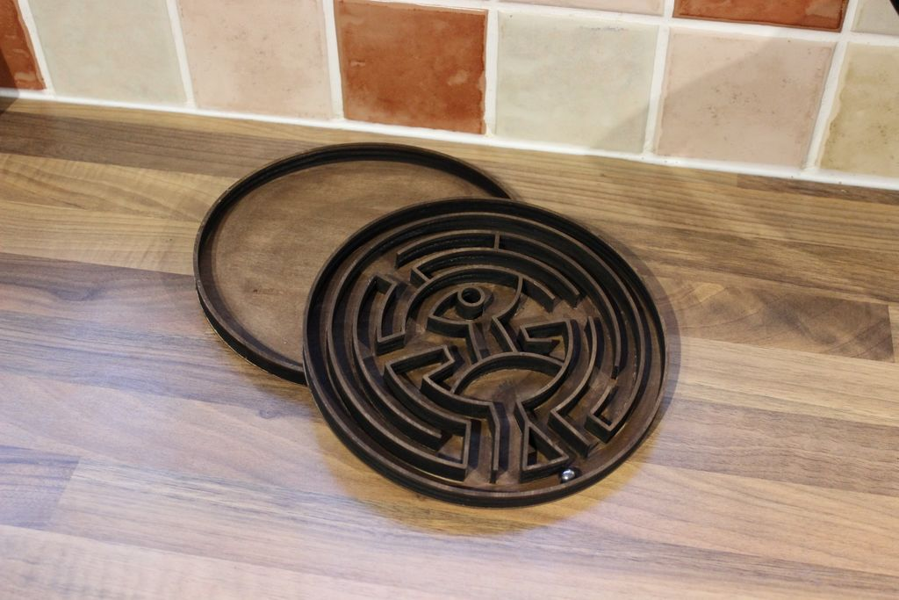

Figure Pinball Maze

However, Novint Falcon only has three translational DOFs, which means it cannot rotate the maze. So, we add two more devices and make them as a system. Then we attach a platform with pinball maze to the system, when the Falcons move their end effector, they will rotate the maze and maneuver the pinball hit the goal.

This path generation problem can be stated as that given the solution path of pinball in the maze, find the motion path of end effectors of three Novint Falcons.

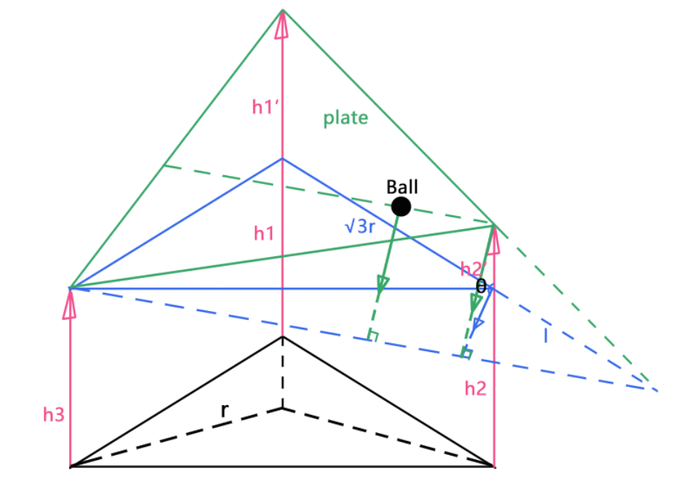

Figure Geometric Configuration of Ball on Plate

To simplify the control strategy, three Novint Falcons only moves in vertical orientation. Figure 5 shows the geometric configuration of the system. , and represents the end effectors with respect to the basement. represents the ball vector with respect to the origin from overlook view.

|  |  |  |  |  |  |
| --- | --- | --- | --- | --- | --- |
|  |  |  |  |  | |
|  |  |  |  |  | |
|  |  |  |  |  | |
|  |  |  |  |  | |
|  |  |  |  |  | |
|  |  |  |  |  | |
|  |  |  |  |  | |
|  |  |  |  |  | |
|  |  |  |  |  | |
|  |  |  |  |  |

Table Geometric Configuration

**Results and Conclusion**

We simulate the methods above in MATLAB and test the kinematics and dynamics configurations by making the Novint Falcon manipulator follow the routine of three-dimensional helix line. The equations of helix line:

% helix

z = 151 : 180;

theta = linspace(-3*pi,3*pi,30);

x = 10*cos(theta);

y = 10*sin(theta);

s = [x;y;z];

First the kinematic configuration is applied, the result turns out to work well, which verifies the feasibility of Tsai and Stamper’s research [1]. The motion video of Novint Falcon is shown in *‘helix.mp4’*.

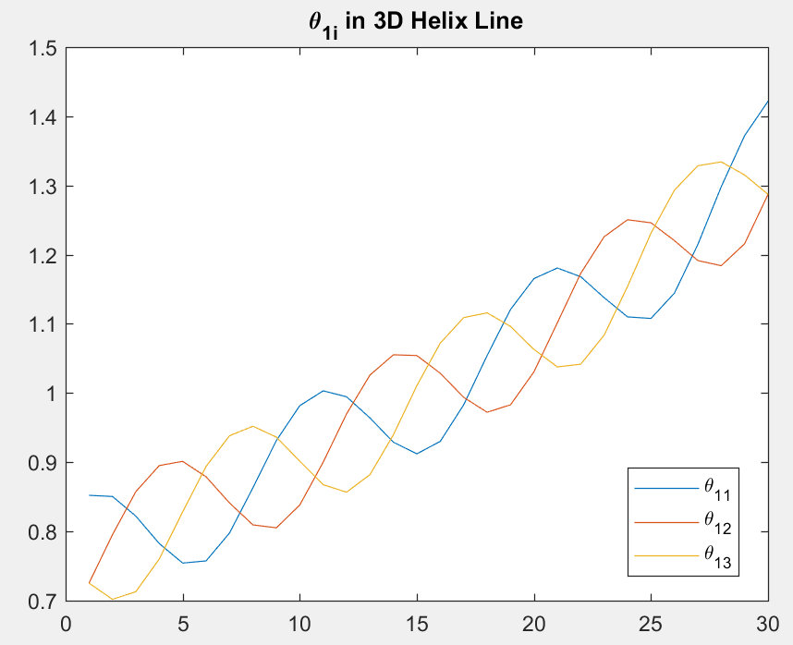

Figure in 3D Helix Line

Then we simulate the dynamic configuration of Novint Falcon to generate torques of three motors when end effector moves in helix line. While calculating the first and second derivatives, we use fourth order accuracy central and forward (backward) finite difference. In addition, we neglect the effect of gravity on the links. The result is shown in Figure 7.

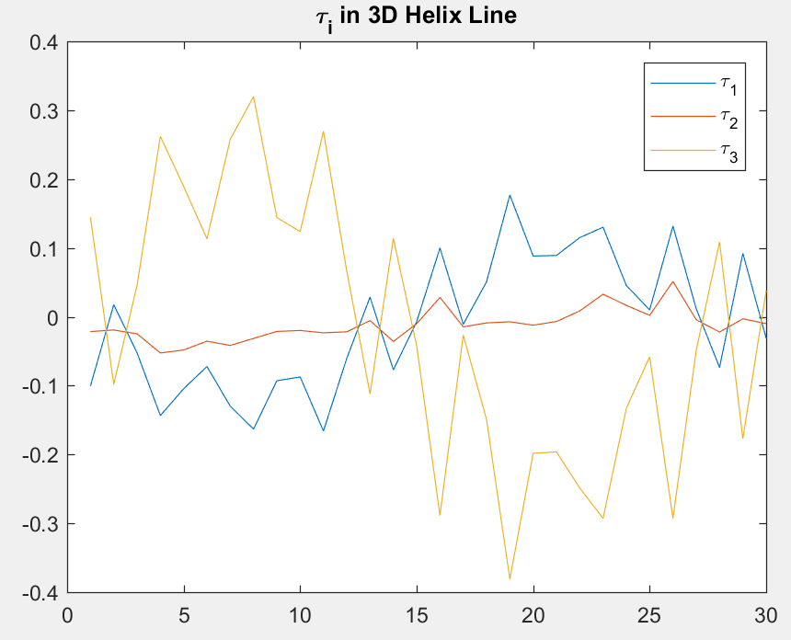

Figure in 3D Helix Line

After that, we research on the path generation problem to solve the pinball maze problem. First, the system is asked to draw a single circle. And the result shows the system can behave in continuous and expected motion.

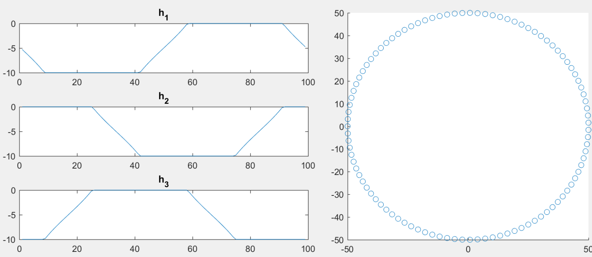

Figure Drawing a Circle

Then we input the maze solution path and generate the variation of *h* to iteration number. The demonstration video is shown in *‘maze.mp4’*.

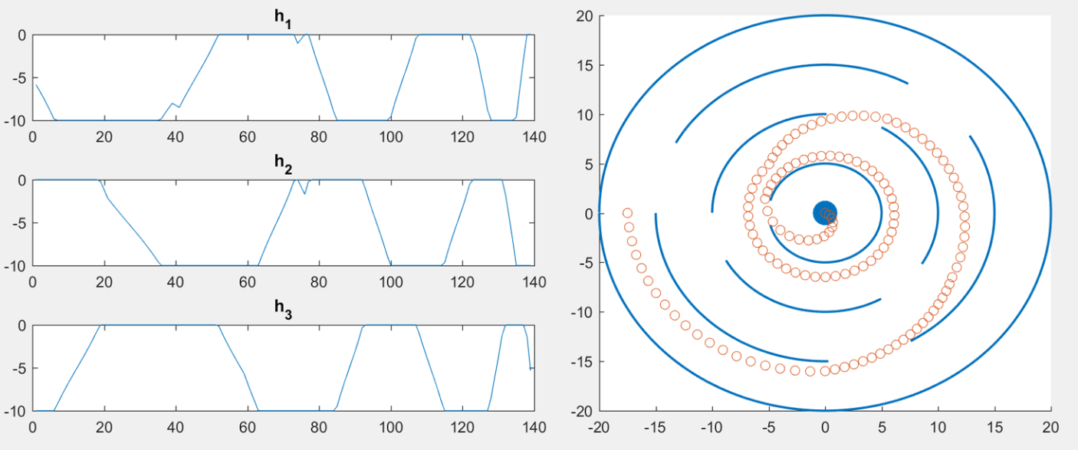

Figure Solving the maze

**Reference**

[1] Block, Daniel J., Mark B. Michelotti, and Ramavarapu S. Sreenivas. "Application of the Novint Falcon haptic device as an actuator in real-time control." *Paladyn, Journal of Behavioral Robotics* 4.3 (2013): 182-193.

[2] Tsai, Lung-Wen, and Richard E. Stamper. *A parallel manipulator with only translational degrees of freedom*. 1997.

[3] Karbasizadeh, Nima, et al. "Dynamic identification of the Novint Falcon Haptic device." *Robotics and Mechatronics (ICROM), 2016 4th International Conference on*. IEEE, 2016.